English Olympiad Questions for Class 1
1. __________ chair is dirty.
a) Most
b) Some
c) The
d) a
Answer: The
2. Complete the word using the letters from the given below options. The magician had clever___ concealed several rabbits in his hat.
a) fully
b) ness
c) ly
d) ity
Answer: ly
3. My sister is a teacher. ____ teaches in the school.
a) He
b) She
c) It
d) They
Answer: She
4. I have _____ orange flower.
a) an
b) some
c) few
d) the
Answer: an
5. Choose the correct word:
_____ raich
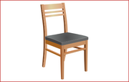
a) airch
b) chair
c) cairh
d) raich
Answer: chair
6. Choose the odd word out.
a) Railway station
b) River
c) Train
Answer: River
7. The _____ is fine today. Let’s go for a picnic
a) Weather
b) Wheather
c) Whether
d) Wether
Answer: Weather
8. ________ books are in my bag.
a) An
b) The
c) An
d) This
Answer: The
9. Unscramble the letters to form a meaningful word) Plca
a) Palc
b) Clap
c) Plac
Answer: Clap
10. Select the item which does not belong to the group:
a) Truck
b) Tractor
c) Bus
d) Aeroplane
Answer: Aeroplane
11. The ______ are going to the school.
a) child
b) children
c) childrens
Answer: children
12. Identify the pronoun in the following sentence:
Give him a pen.
a) Give
b) A
c) Him
d) Pen
Answer: Him
13. Write the name of the vegetable shown in the picture below, as per given hint. (c _____ r)
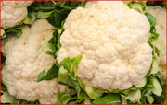
a) Cauliflower
b) Caliper
c) Carpenter
d) Carder
Answer: Cauliflower
14. Look at the picture and choose the right answer:
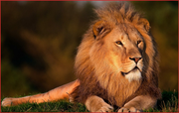
My name is Bunny. I’m a __________.
a) dog
b) wolf
c) lion
d) cat
Answer: lion
15. Choose the right answer.
Tom : Jerry! Don’t make a noise.
Jerry : __________________.
a) I am not a teacher, Tom
b) Thank you, Tom
c) Sorry, Tom
Answer: Sorry, Tom
16. Identify the noun in the following sentence: Ninni ran faster than tinny.
a) ran
b) faster
c) than, tinny
d) Ninni, Tinny
Answer: Ninni, Tinny
17. Identify the verb
'Monika sleeps on sofa’
a) Monica
b) Sleeps
c) Sofa
Answer: Sleeps
18. What is the Baby of 'monkey' called?
a) duckling
b) calf
c) foal
d) infant
Answer: infan
19. Complete the given correlation.
Rose : Shrubs : : Mango : ?
a) Tree
b) Climber
c) Shrubs
d) Herbs
Answer: Tree
20. What letter comes between n and p?
a) q
b) m
c) o
d) None of these
Answer: o
21. Which one of the following options represents the figure in correct alphabetical order?
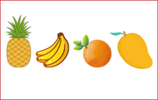
a) Orange, banana, mango, pineapple
b) Banana, mango, orange, pineapple
c) Banana, orange, pineapple, mango
d) All of these
Answer: Banana, mango, orange, pineapple
22. What is the Baby of 'bear' called?
a) bunny
b) owlet
c) calf
d) cub
Answer: cub
23. Choose the action verb from the options given:
Cobblers mend our shoes.
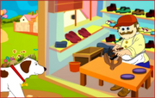
a) Cobblers
b) Shoes
c) Mend
d) All of these
Answer: Mend
24. Which of the following option gives us heat and light?
a) Moon
b) Sun
c) Satellite
d) Planet
Answer: Sun
25. Fill in the blank with a or an.
He is _____ lawyer.
a) a
b) an
c) Both a and b
d) None of these
Answer: a
26. Identify the action word in the given sentence.
Their dog chased our cat.
a) cat
b) dog
c) their
d) chased
Answer: chased
27. Which one of the following options is correct for the given picture?
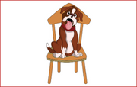
a) A dog is sitting on the chair.
b) A dog is sitting in the chair.
c) A dog is sitting at the chair.
d) All of these
Answer: A dog is sitting on the chair.
28. Fill in the blank with missing letter as per given hint.
S __ N
a) 0
b) U
c) A
d) None of these
Answer: U
29. Identify the plural of the word given in capital letters:
FOOT
a) Foots
b) Feet
c) Feetes
d) None of these
Answers: Feet
30. Choose the rhyming word of TALK.
a) Work
b) Walk
c) Sleep
d) None of these
Answer: Walk
31. Identify the picture:
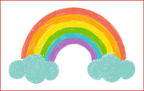
a) Bubble
b) Rainbow
c) Sun
d) Star
Answer: Rainbow
32. Identify the misspelled word
a) Large
b) Thin
c) Weeak
d) None of these
Answer: Weeak
33. In the following figure, find the word that has two alphabets of vowel:
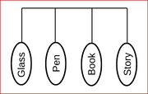
a) Glass
b) Pen
c) Book
d) Story
Answer: Book
34. What is the masuline gender of cow?
a) Bull
b) Oxen
c) Mule
d) Hog
Answer: Bull
35. Arrange the jumbled words to make a meaningful sentence. father, is, your, pilot, a
a) Your father a pilot is.
b) Father your is a pilot.
c) Your father is a pilot.
d) None of these
Answer: Your father is a pilot.
36. What is the plural form of Leaf?
a) Leafs
b) Leafes
c) Leavs
d) Leaves
Answer: Leaves
37. What is the tenth letter of the alphabet?
a) K
b) O
c) J
d) None of these
Answer: J
38. What is the masculine gender of hen?
a) Hen
b) Rooster
c) Pea Hen
d) Drake
Answer: Rooster
39. Identify the picture and fill in the blanks to form the correct spelling:
BALL_ _N
a) BALLUUN
b) BALLOON
c) BALLUON
d) BALLOUN
Answer: BALLOON
40. Find the same meaning (Synonym) of SHORT.
a) Long
b) Little
c) Lazy
d) None of these
Answer: Little
41. Look at the picture and choose the right answer:
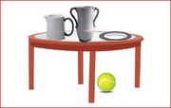
The ball is __________ the table.
a) in
b) under
c) on
d) a
Answer: under
42. Which word describes the picture below?
a) Singing
b) Dancing
c) Reading
d) Swimming
Answer: Reading
43. Fill in the correct alphabet to make the word correct
Tomo_ _ow
a) ee
b) rr
c) cc
d) none of these
Answer: rr
44. Which letter comes just before K?
a) O
b) L
c) J
d) M
Answer: J
45. Identify the misspelled word
a) Some
b) Same
c) Souce
d) Salt
Answer: Souce
46. Arrange the jumbled words to make a meaningful sentence:
Eat, I, food, healthy.
a) Eat healthy food I
b) I healthy eat food
c) I eat healthy food
d) None of these
Answer: I eat healthy food
47. Arrange the alphabets to make a meaningful word:
SAWH
a) Haws
b) Sawh
c) Wash
d) None of these
Answer: Wash
48. Choose the action verb from the option given:
The gardener waters the plants.
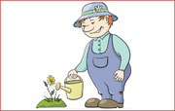
a) Waters
b) Plants
c) Gardener
Answer: Waters
49. Fill in the blank with a suitable article:
I saw _____ lion in the zoo.
a) a
b) an
c) the
d) no article
Answer: a
50. Mark the letter which will make both the words correct.
s _ d, b _ d
a) a
b) o
c) n
d) none of these
Answer: a

