7 r SINIF

TMY - 2023

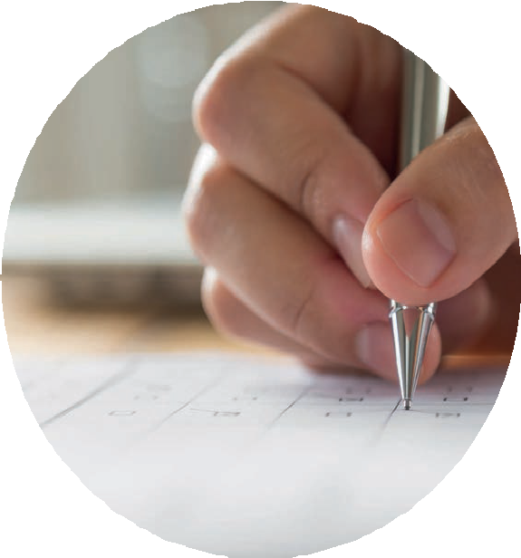

AD SOYAD :

OKUL ADI : SINIF :

www.turkiyematematikyarismasi.com

1. = a 3 and

a

= b2
b

3. Below are the blue and black bars and the lengths of bars are given in cm.

symbols are defined.

So,

5 cm

6 cm
8
· 16

+

4
8

which of following options is equal to the result of the process?

- B) C)

16
8
32
The blue bar is divided into 4 equal parts and the black bar is divided into 5 equal parts. Ela sees that a red stick piece in her hand is shorter when she compares it with one of the blue pieces, and longer when she compares it with one of the black pieces.

Accordingly, which of the following could be the length of the red stick in Ela's hand?

A) 1,15 B) 1,18 C) 1,20
D) 1,24 E) 1,28

E)
D)
32
64
Türkiye Matematik Yarışması

2. Menekşe decides to paint all the squares of the 24 unit square figure below in one of the colors blue, red, and green. First of all, he paints all the squares which she will paint blue as follows.

Since he will paint the ratio of the number of red squares to the number of green squares to be 1/3 that he will paint later, how many of all the squares will be painted green after this painting process is done.
A, B and C are numbers. Emir was born in 20AB year, Omar was born in 20AC year.

If the product of the ages of the two is 35 in 2023, what is A + B + C?

A) 15 B) 17 C) 21 D) 23 E) 25

- Exponential expressions with a base of 10 have as many zeros as the exponent at the end.

For example, 10⁴ = 10000, if the sum of the digits of 10n – 3 for the natural number n is 250, what is n?

A) 20 B) 22 C) 24 D) 26 E) 28

7. Ali has a 120 cm long piece of wire in his hand. With this piece of wire, he wants to make an equilateral triangle with a side of 3 cm, a square with a side of 2 cm, and a regular pentagon with a side of 1 cm.
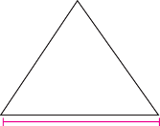
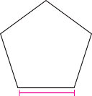
3 cm 2 cm 1 cm

How many shapes will he get at most with making at least one of each triangle, square and pentagon with the whole of the Ali wire?
Türkiye Matematik Yarışması

A) 17 B) 18 C) 19 D) 20 E) 22

6. Murat wants to buy a bike.
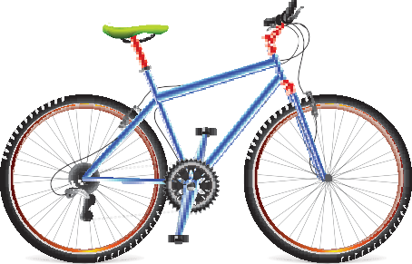

If Murat can buy the bike by saving 20% of the bike price in the first week, 60% of the remaining amount in the second week, and 960 liras in the third week, how much is this bike?

A) 3000 B) 3200 C) 3600 D) 4200 E) 4800

8. When the necessary settings are made, a video can be watched in a shorter time by increasing the normal flow rate. For example, a 30-minute video can be watched in 15 minutes at 2x speed and in 10 minutes at 3x speed.

Accordingly, if 1/4 of a 2-hour video is watched at normal speed, 1/3 of the rest at 2 times speed, and the rest at 3 times speed, how many minutes in total will it be watched?

A) 45 B) 65 C) 75 D) 80 E) 90

9. T+M+Y + T+M+Y + T+M+Y = 23
T+M T+Y M+Y

is given and find the following.

T + M + Y

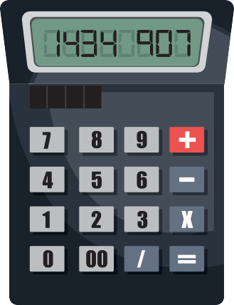
- A broken calculator does not show operations correctly and does not display some numbers in the result. Selçuk sees the result as follows with calculating the value of the expression $3^{15}$ with this calculator.

M+Y
T+Y
T+M

  - 19 B) 20 C) 21 D) 22 E) None
Türkiye Matematik Yarışması

10. Kenan chooses and multiplies any five of the numbers 2, 3, 5, 6, 8 and 9.

Kenan's result is exactly divisible by which of the following?

A) 24 B) 27 C) 30 D) 32 E) 36

Accordingly, what is the number that does not appear on the calculator screen?

A) 4 B) 5 C) 6 D) 7 E) 8

- p and p² + 8 numbers are prime numbers.

Which of the following numbers are exactly prime?

A) 12p² + 3 B) p³ + p² – 1
C) 5p² + 4 D) p³ + 16 E) p³ + 12

- While celebrating his son Emir's 3rd birthday in 2022, Ali Bey realizes that the number 2022 is divisible by 3 and gets another special gift for Emir this year. But next year, 2023 is not divisible by 4, so he doesn't get any birthday gift this year.

Accordingly, how many times does Ali Bey buy a special gift from 2024 to 2100?

A) 0 B) 1 C) 2 D) 3 E) 4

- Using the digits 1, 2, 3, 4, 5 all exactly once, two numbers are written, one with 3 digits and the other with 2 digits. When a 3-digit number is divided by a 2-digit number, the remainder is zero.

Which of the following can be the divisor number?

A) 12 B) 13 C) 14 D) 15 E) 21

- A ship is hiding on the 6x6 unit square floor. This ship consists of 4 consecutive unit squares in the same row or same column.
Marking n unit squares to pinpoint at least 1 piece of this ship.

What n can be at least ?
Türkiye Matematik Yarışması

A) 5 B) 6 C) 7 D) 8 E) 9

- A cashier selling tickets numbered 1, 2, 3, ... notes down the numbers of the seats he sells. When he checks his notes after selling all the tickets, he realizes that he noted a number twice.

If the sum of the seat numbers of all the tickets that the cashier notes is 857. Which seat did he note twice?

A) 37 B) 38 C) 39 D) 40 E) 41

- The letters of the AYA MAYA tribe are composed of capital letters with the same mirror image in the Turkish alphabet. The features of the words in the dictionary of this tribe are as follows.

  - The mirror image of all words is the same. For example MAYAM, MAM, YAY
  - Two vowels or consonants cannot come together.
  - A letter can be used at most 2 times in a word.

How many letters can the longest word in this tribe have?

A) 18 B) 19 C) 20 D) 21 E) 24

- Prime numbers have only 2 positive divisors; one and itself . If a positive integer has only 3 positive divisors, let's call it a almost prime number.

How many almost prime numbers less than 100 are there?

A) 9 B) 8 C) 6 D) 5 E) 4

- The six numbers obtained by adding four different natural numbers by twos are ordered from smallest to largest, and the first four of the six numbers are 12, 17, 19, 23.

So, what is the sixth number?

A) 25 B) 27 C) 29 D) 30 E) 32
Türkiye Matematik Yarışması

- In a tournament where 4 teams participated, each team played one match against each other. In this match, 3 points are awarded for a win, 1 point for each team in case of a draw, and 0 points for the losing team.

If we denote the score of any team with p, then how many integer values p cannot take in this interval
0 ≤ p ≤ 10 ?

A) 2 B) 3 C) 4 D) 5 E) 6

- Three rectangles with integer side lengths have different perimeters, but have the same area with 108 cm² dir.

If the perimeter of the rectangle with the largest perimeter is x cm and the perimeter of the rectangle with the smallest perimeter is y cm, what is the x – y difference?

A) 160 B) 168 C) 172 D) 176 E) 180

23. A square is divided into two rectangles. The perimeters in centimeters are written inside the resulting rectangles.
50
58

What is the area in cm² of the initial square ?
Türkiye Matematik Yarışması

A) 225 B) 256 C) 289 D) 324 E) 361

22. Regions denoted by the letters A, B, and C in the figure below are squares, each having an area in square centimeters equal to a positive perfect square number greater than 30.

A | B |  | C
A
A | A | A

24. For a two-digit positive integer n,

1 + 2 + 3 + ... + n

the sum is divisible by 12 without a remainder..

What is the sum of the digits of the smallest number n?

A) 12 B) 10 C) 8 D) 7 E) 6

Accordingly, the perimeter of the rectangle formed can be at least how many centimeters?

A) 84 B) 88 C) 96 D) 108 E) 120

Türkiye Matematik Yarışması

www.turkiyematematikyarismasi.com

8

