4 SINIF

TMY - 2023

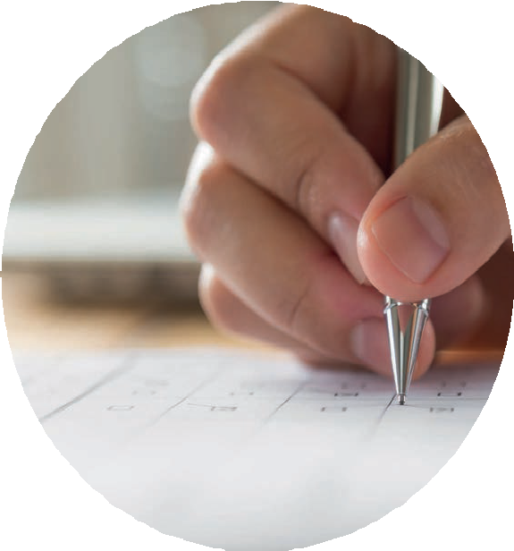

AD SOYAD :

OKUL AD : SINIF :

www.turkiyematematikyarismasi.com

- Numbers from 1 to 6 will be used only once and placed in the table below with 2 squares filled in all rows and columns. In this layout, the product of two numbers in each row is written in the rightmost square of that row, and the product of two numbers in each column is written in the bottom square of that column.

 |  |  | 18
 |  |  | 4
 |  |  | A
3 | 20 | 12

Which number should be instead of A?
Türkiye Matematik Yarışması

A) 6 B) 8 C) 10 D) 12 E) 15

- A B
C C C

- The chess club has two rectangular rooms. The length of first room is 5 meters, the width is 4 meters. The second room has the same width, but the length is more 2 meters. Therefore, 800 pounds more paint is used to paint the ceiling of the second room.

How many pounds paint should be used to paint the ceiling of both rooms.

A) 4400 B) 4800 C) 5200 D) 5600 E) 6000

- Zeynep has read one-fourth of a storybook and Merve has read one-third of the same storybook.

+ C C C

2 0 2 3

In this addition, AB is a two-digit number and CCC is a three-digit number.

So, find A x B x C.

A) 60 B) 75 C) 80 D) 84 E) 90

If Merve reads 30 more pages than Zeynep, how many pages are in this storybook?

A) 288 B) 300 C) 336 D) 360 E) 420

- Below each of the shapes formed with matchsticks 7.
it is written how many matchsticks were used.
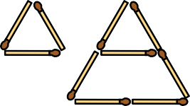
3
7

12

How many matchsticks are used for 10 shapes?
What fraction of the square above is painted blue?

A) 65 B) 68 C) 72 D) 75 E) 78
  - 15
64
  - 15
32
  - 5
16
  - 3 8
  - 3 4

- Ahmed takes 3 steps in 2 seconds while walking from home to school at a constant speed.

If there are 2430 steps between Ahmad's house and school and if Ahmet leaves the house at 7:25, What time does Ahmad arrive at school?

A) 7:40 B) 7:45 C) 7:52 D) 7:56 E) 8:00
- Arda had the following conversations with his parents about the old carpet in their house.

Mother: Arda, when we got married to your father in 2000, the age of this hand-woven carpet that I brought in my dowry was 30 more than the sum of my age and your father's age.
Father: When you were born in 2010, the sum of my age with your mother was 72.
Arda: If the carpet is 100 years old this year, in which year will the sum of the ages of the three of us equal the age of the carpet?

According to these conversations, what is the answer Arda’s question?

A) 2023 B) 2022 C) 2021 D) 2020 E) 2018

- We have 8x8, 4x4 and 2x2 squares which are given below.

8 4 2
2
4
8

11. A number of stones with integer weights can be shared between 3 people and 5 people. Each of stones has the same weight.

What is the minimum number of these stones?
A) 10 B) 9 C) 8 D) 7 E) 6

Accordingly, what is the minimum number of squares used in the smallest sized square that can be created by using at least one of each of these squares?

A) 8 B) 9 C) 10 D) 12 E) 13

10. A 5-storey tower will be created using the same cube. 2 cubes will be used on the first floor of the tower. But, no more cubes will be used on each floor of the tower than a lower floor.

Accordingly, in how many different ways this tower can be formed in terms of the number of cubes on the floors?

A) 1 B) 3 C) 4 D) 5 E) 6
12.

C |  |  |  | 6
x |  |  |  | x
5 |  | 12 | x |  | = | B
= |  |  |  | = |  | +
D | = | 55 | + | A |  | 15
 |  |  |  |  |  | =
 |  |  |  |  |  | 75

If addition and multiplication is completed in the table, find this expression.

A + B + C + D

A) 190 B) 195 C) 191 D) 206 E) 192

- Ismet first divides the cake that is prepared for his birthday into 4 equal parts. He divides two of these pieces into 5 equal pieces to share to his friends, and he divides the remaining two pieces into 3 equal pieces to share to other guests.

If 4 large pieces and 7 small pieces were eaten, what fraction of the full cake was eaten?

- As an example is given below, each of the numbers from 1 to 6 is placed in 6 round divisions. Then, the numbers in the corners of the triangles are added together and written. Finally, the TMY value of the shape is calculated by adding the numbers inside the triangles.

Example

  - 31
60
  - 37
60
  - 41
60
  - 43
60
  - 47
60
1

6
2
3
10
11
14
4 5 6
?
?
?
?
?
?

TMY value: 6 + 11 + 10 + 14 = 41
Türkiye Matematik Yarışması

What is the minimum TMY value of a shape like the one in the example?

A) 38 B) 36 C) 34 D) 33 E) 32

14.

30 m
90 m
40 m
70 m
50 m

20 m

120 m

16. 12

a

80 m

In this figure, in the walking track the dashed lines are in the middle of the track.

How many meters does a person walking over the dashed lines when he completes the track?

A) 240 B) 245 C) 260 D) 275 E) 285

The board above was made from rectangular cardboards with a short side length of 12 cm. One side of the board is shown by a.

How many cm is a?

A) 84 B) 78 C) 72 D) 68 E) 60

- A, B and C are different number. AB and BC are two-digit consecutive even numbers.

If A < B , find A + B + C .

A) 13 B) 14 C) 15 D) 16 E) 17

- Below the figures and the circumference of the
whole figure is given under each figure in cm with particularly rule.

The rectangle above, whose circumference is 100 cm, is divided into seven squares.

What is the perimeter of one of the smaller squares, in cm?

 | 24 | A |  |  |  | 6
A) 12 B) 16 C) 20 D) 24 E) 28

16 16

16
(64)
  - picture

16
8
16 8
(80)
  - picture

4
16 8 4
8
(88)
  - picture
In the above table, the sum of the numbers in each consecutive three box is equal to 60.

What is the number of A?

A) 26 B) 28 C) 30 D) 32 E) 34

By this particularly rule what is the perimeter of 5 shapes
with cm?
A) 94 B) 92 C) 90 D) 96 E) 98

Türkiye Matematik Yarışması

www.turkiyematematikyarismasi.com

Türkiye Matematik Yarışması

www.turkiyematematikyarismasi.com

